CRM

# **WHAT IS CRM?**

* CRM stands for **Customer Relationship Management**. It refers to a set of strategies, practices, and technologies that businesses use to manage and improve their interactions with current and potential customers.
* It is both a business strategy and a set of technologies used to manage and analyze interactions and relationships with customers and potential customers. CRM focuses on improving the overall customer experience, enhancing customer satisfaction, and increasing customer loyalty.

# **EXISTING PHYSICAL SYSTEM**

* Various problems of physical system are described below:
  + **Data Storage and Retrieval** : Physical CRM systems rely on paper records, filing cabinets, and physical documents. This can make it cumbersome to store and retrieve customer information, especially as the volume of data grows.
  + **Data Security** : Physical CRM systems are inherently less secure than digital systems. Paper records can be lost, stolen, or damaged, leading to potential data breaches and privacy concerns.
  + **Limited Accessibility** : Physical records are typically stored in a physical location, making it difficult for remote or off-site teams to access customer information. This can hinder collaboration and responsiveness.
  + **Environmental Impact** : Physical CRM systems contribute to paper waste, which can have a negative impact on the environment.

# **PROPOSED SYSTEM**

* A **Customer Relationship Management (CRM)** system software is a technology tool or platform designed to help businesses manage and optimize their interactions and relationships with customers and potential customers. CRM software provides a centralized database for storing customer information and enables businesses to track and analyze customer interactions, sales, marketing campaigns, and customer service activities.
  + **Marketing Automation :** Many CRM systems integrate with marketing tools and provide features for email marketing, lead nurturing, campaign management, and customer segmentation.
  + **Workflow Automation:** CRM systems often allow businesses to automate repetitive tasks and workflows, streamlining processes and reducing manual data entry.
  + **Mobile Accessibility:** Many modern CRM solutions offer mobile apps or mobile-friendly interfaces, enabling sales and support teams to access customer data and perform tasks while on the go.
  + **Data Security:** CRM systems prioritize data security and offer features for user access control, data encryption, and compliance with data protection regulations.

# ER Diagrams

1. ENTITIES
2. Customer ->

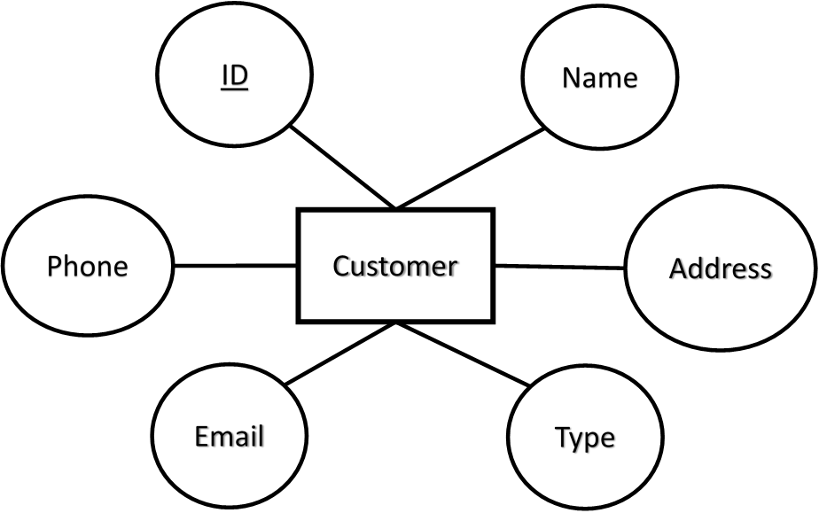

1. Leads ->

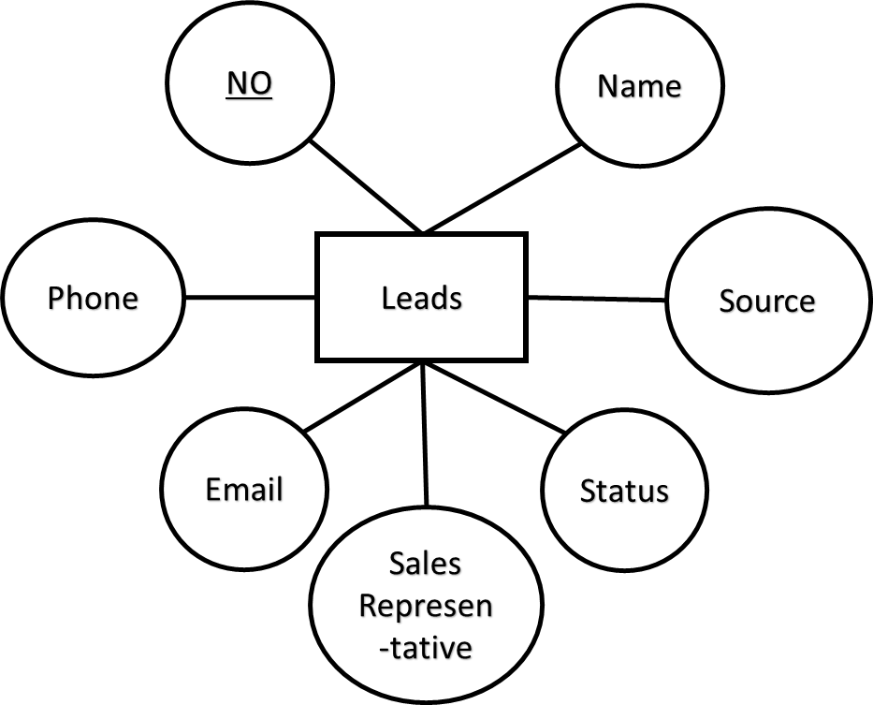

1. Opportunity ->

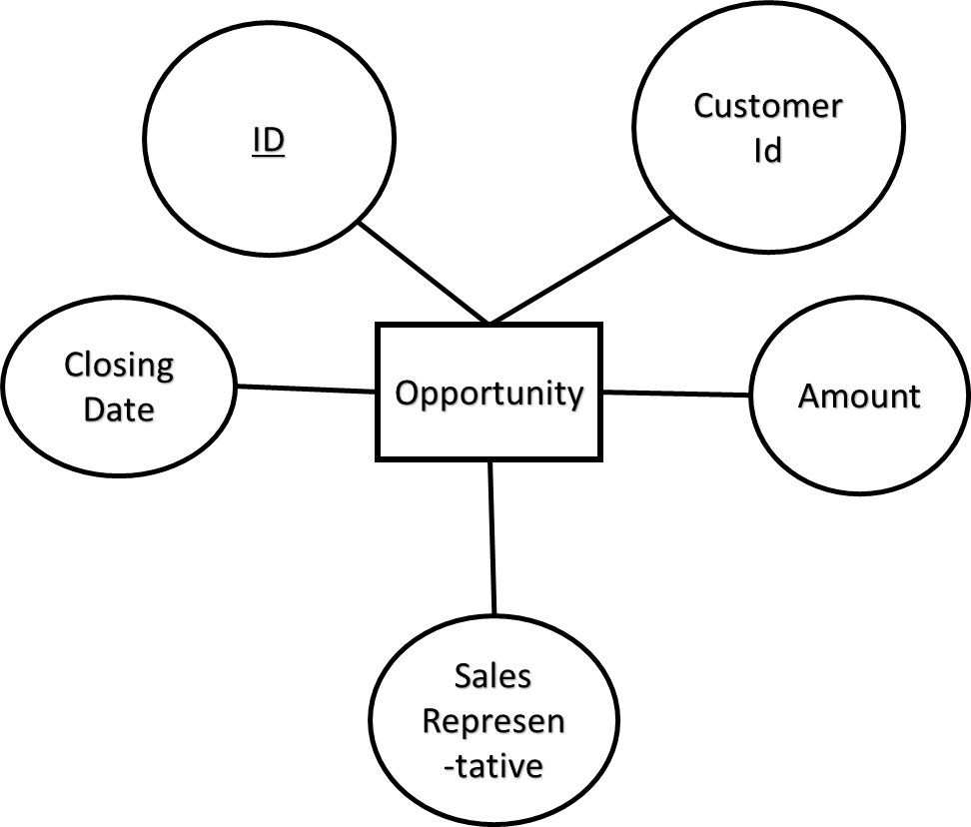

1. Sales Representative ->

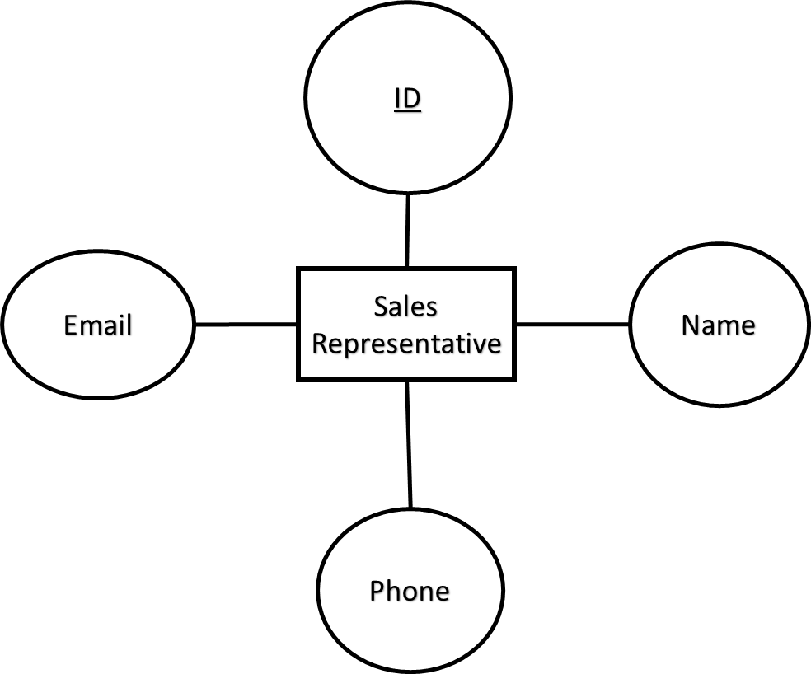

1. Customer Interaction ->

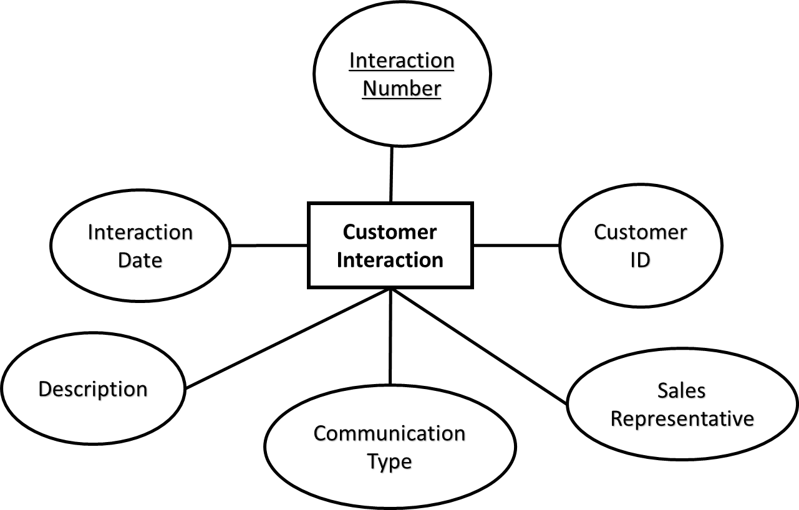

1. Leads Interaction ->

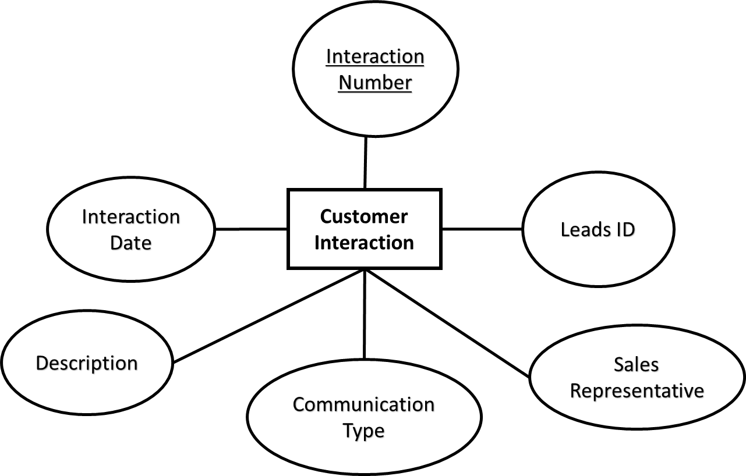

1. Customer Tasks ->

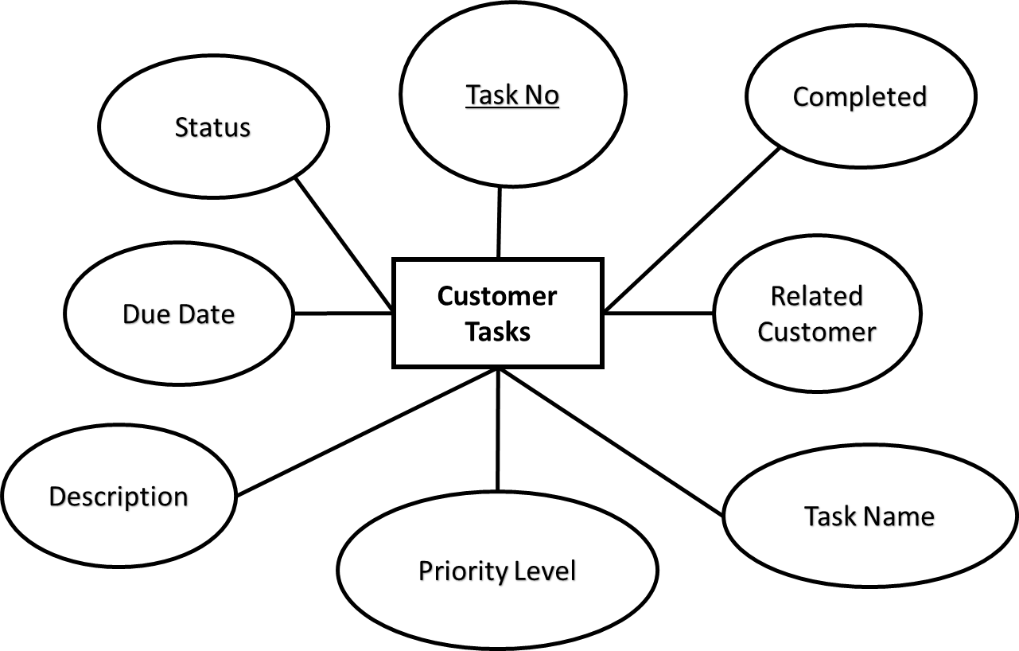

1. Leads Tasks ->

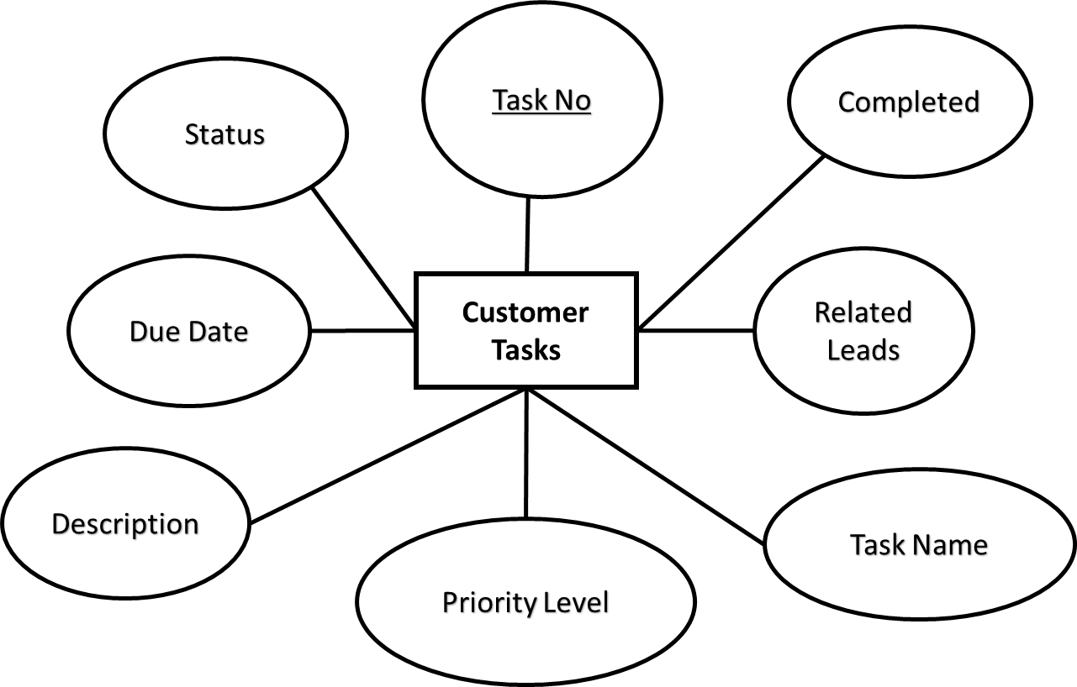

1. Opportunity Tasks ->

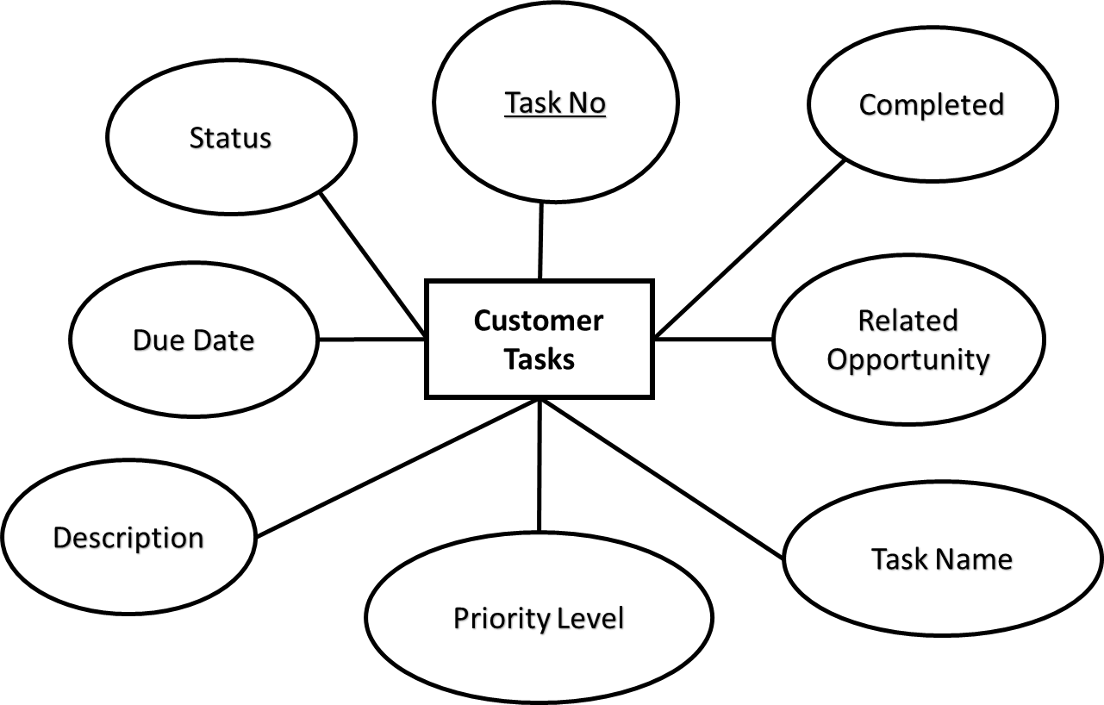

1. RELATIONSHIPS
2. Sales-Representative to Leads

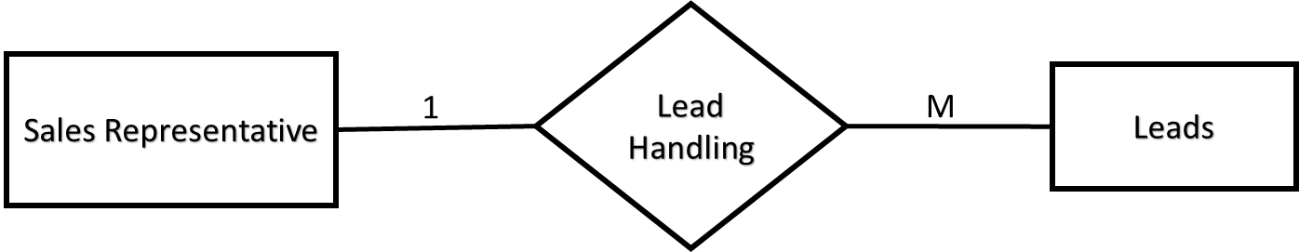

1. Sales-Representative to Leads Interaction

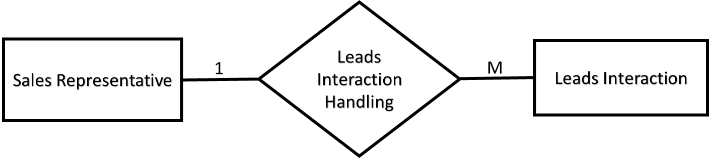

1. Sales-Representative to Customer Interaction

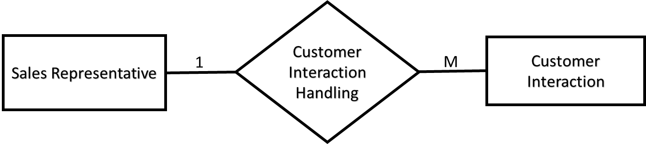

1. Sales-Representative to Opportunity

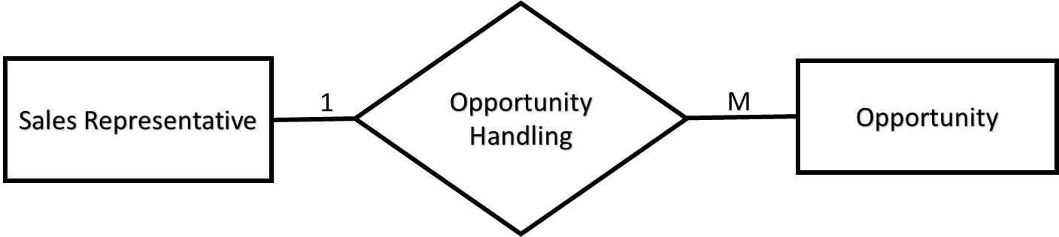

1. Customer to Customer Tasks

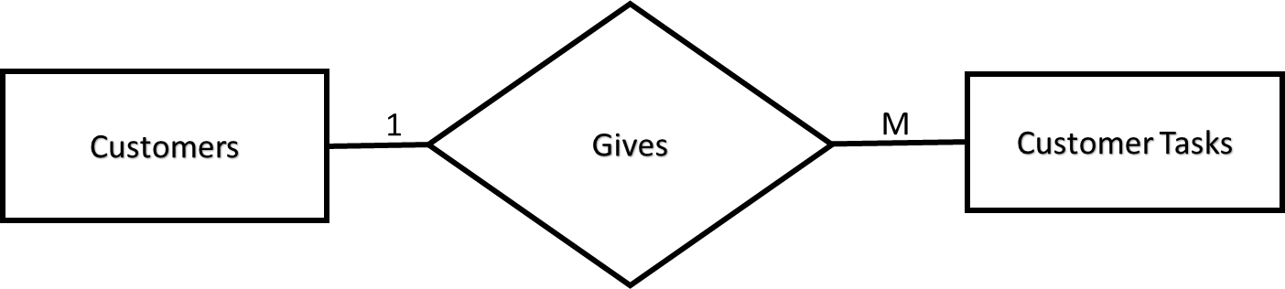

1. Customer to Customer Interactions

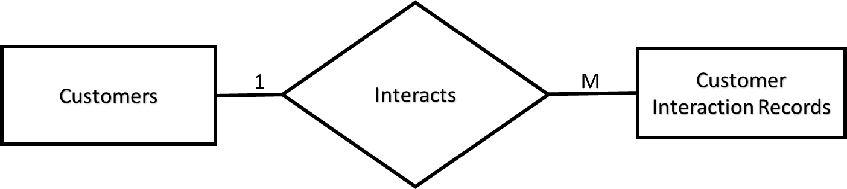

1. Customer to Customer Interactions

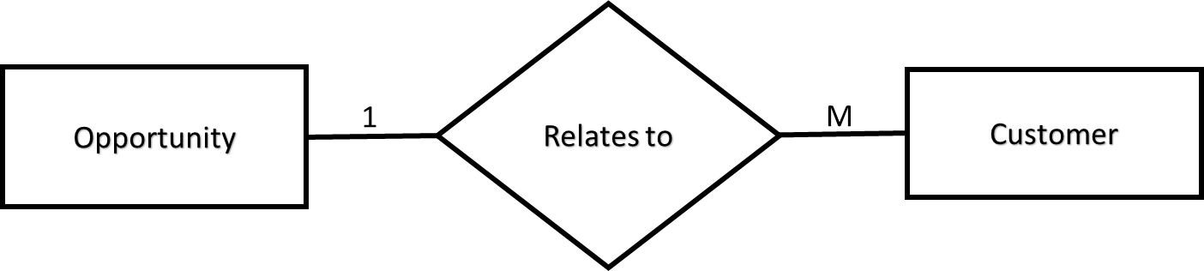

1. Leads to Leads Tasks

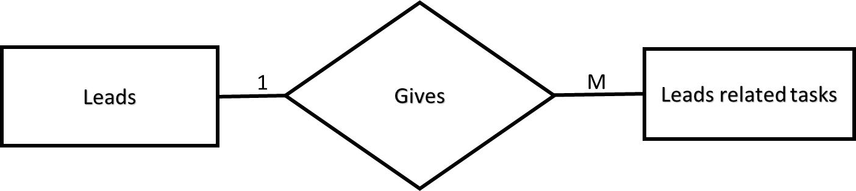

1. Leads to Leads Interactions

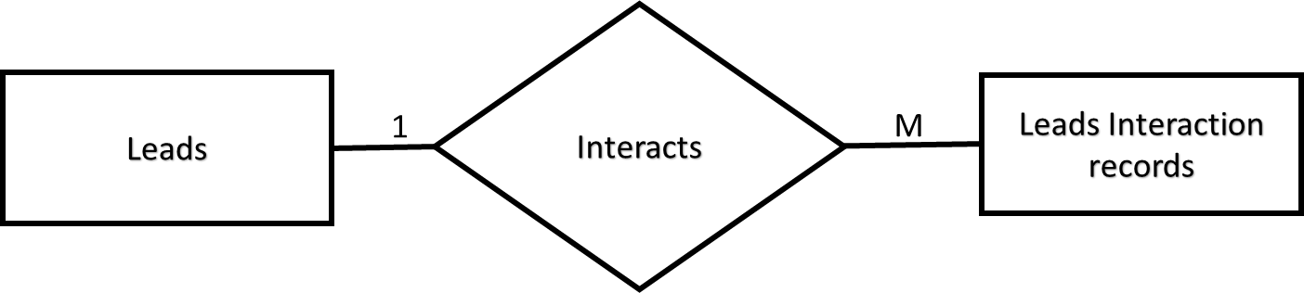10.Opportunity to Opportunity Tasks

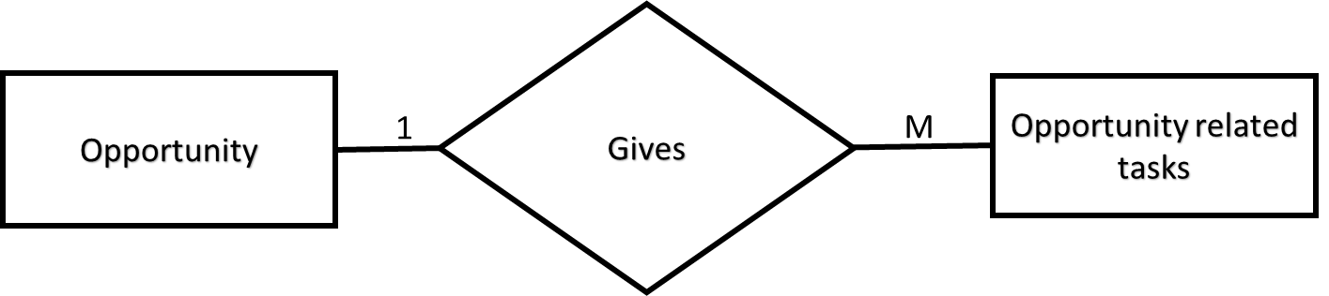

# PROJECT ->

1. Tables ->
   1. Customer

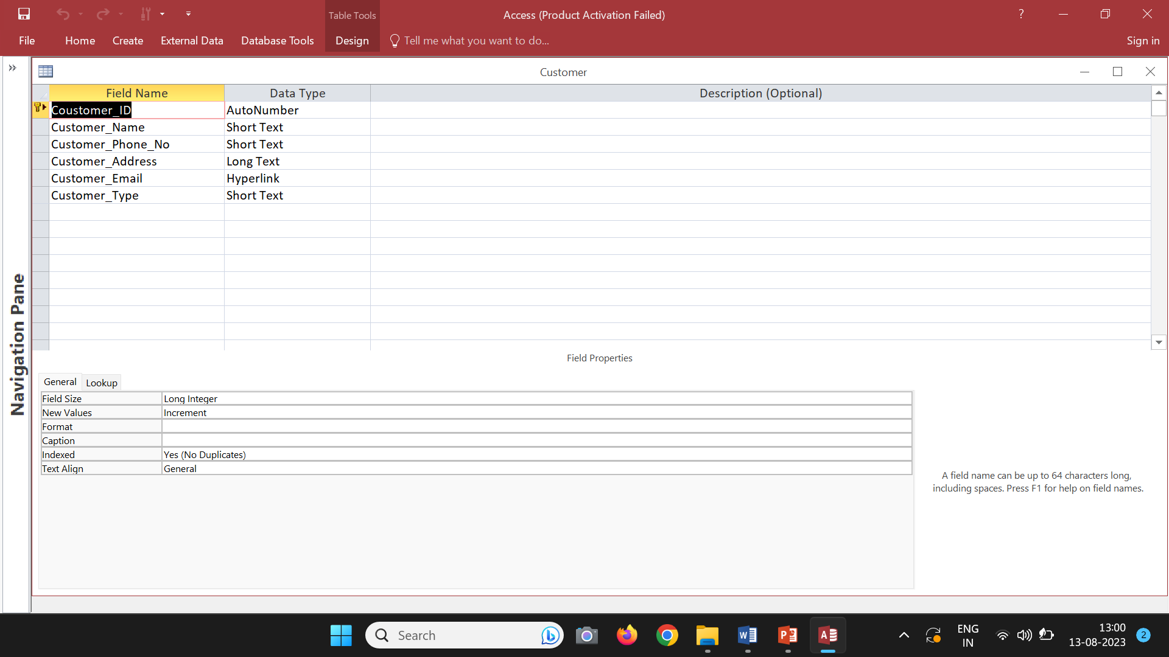

* 1. Leads 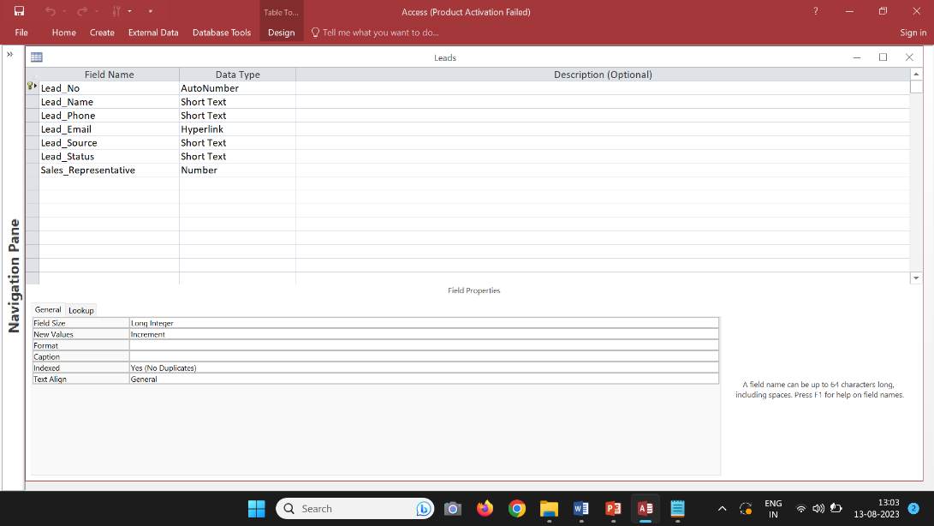
  2. Opportunity

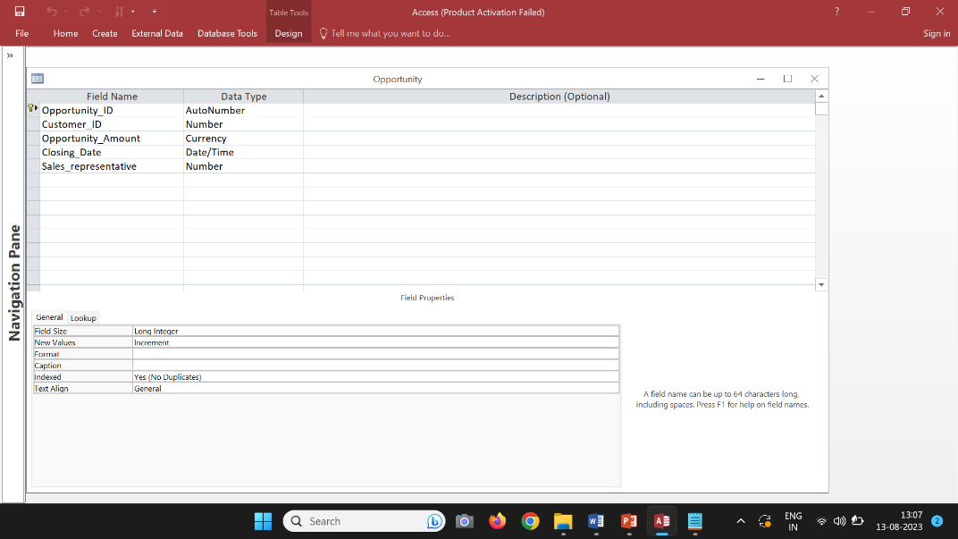

* 1. Sales Representative

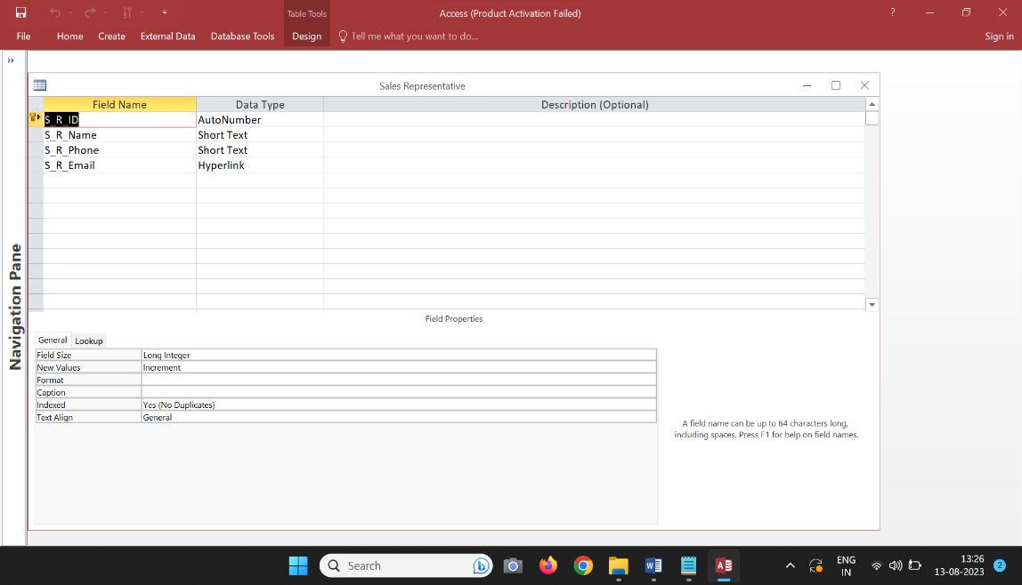

* 1. Customer Task

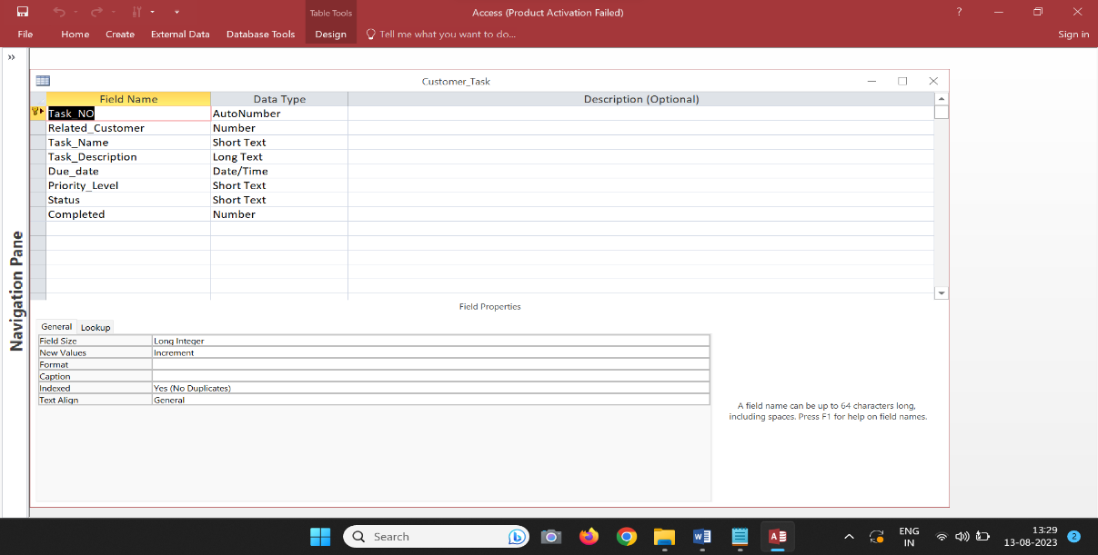

* 1. Leads Task

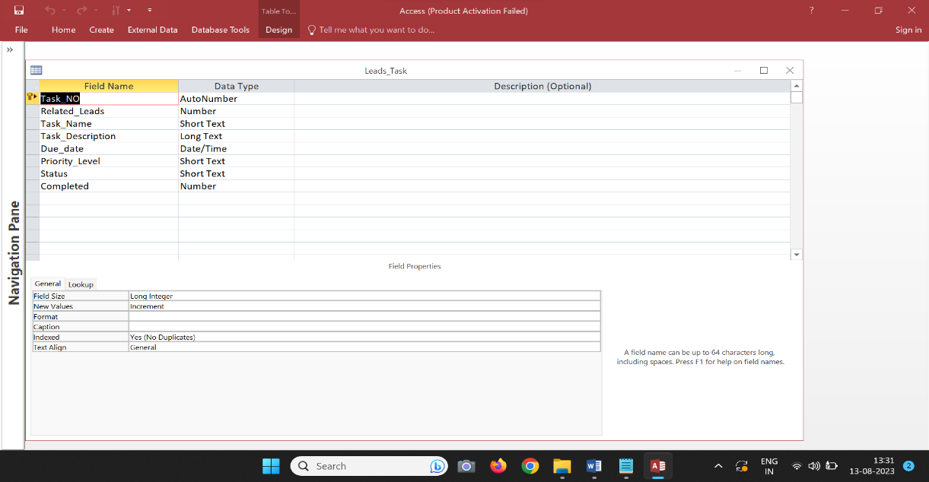

* 1. Opportunity Task

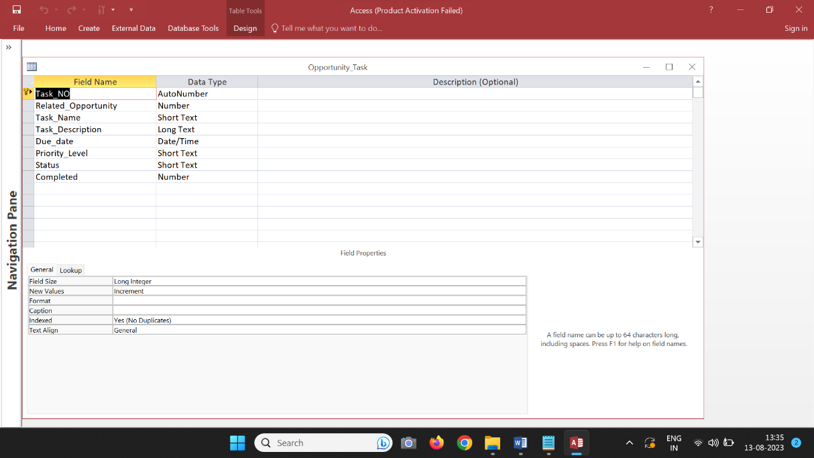

* 1. Customer Interaction

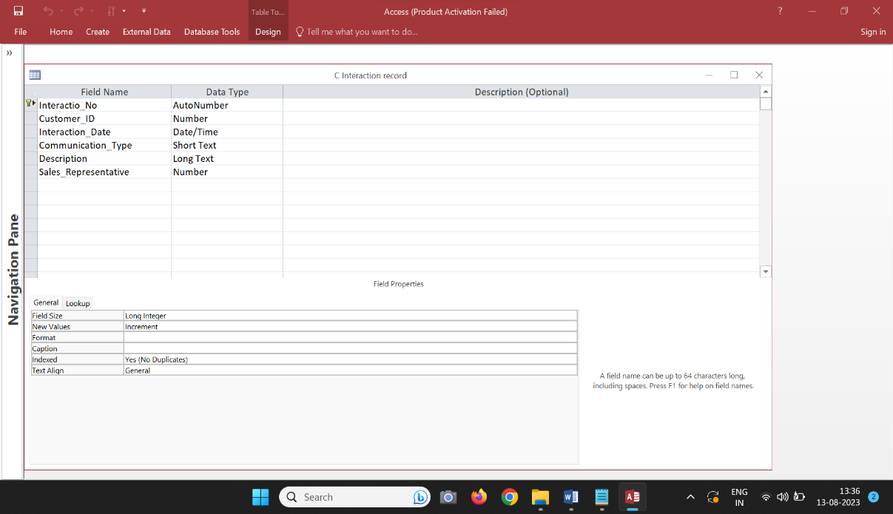

* 1. Leads Interaction

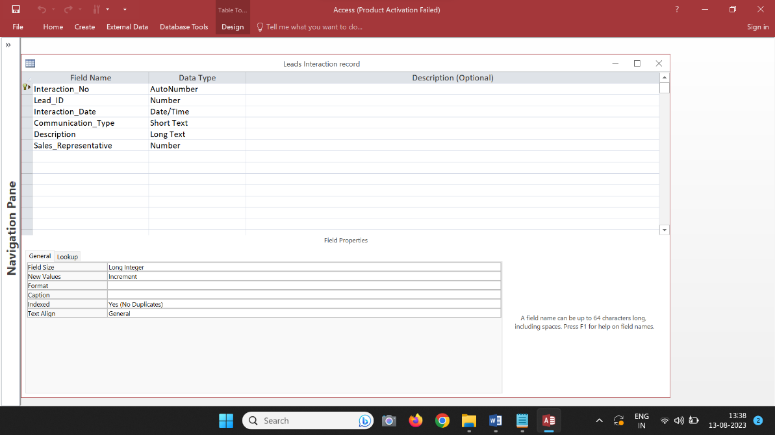

1. Relationships ->

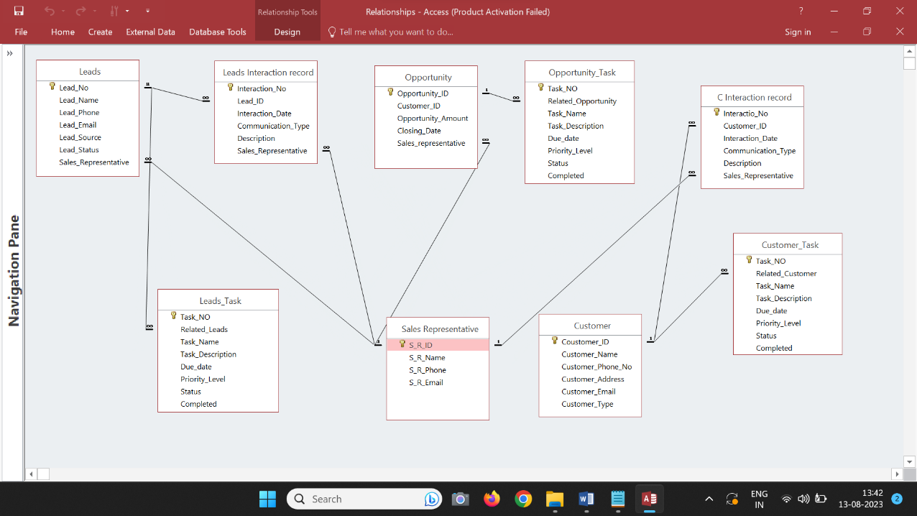

1. Forms ->
   1. Main 🡪

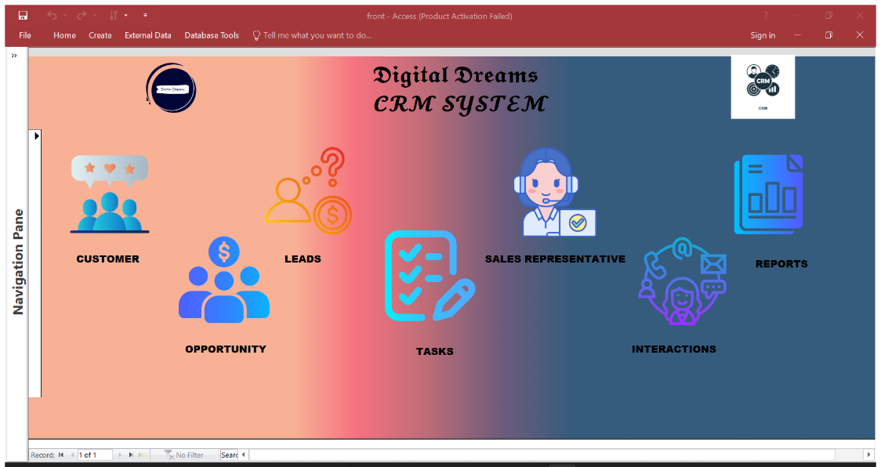

* 1. Customer 🡪

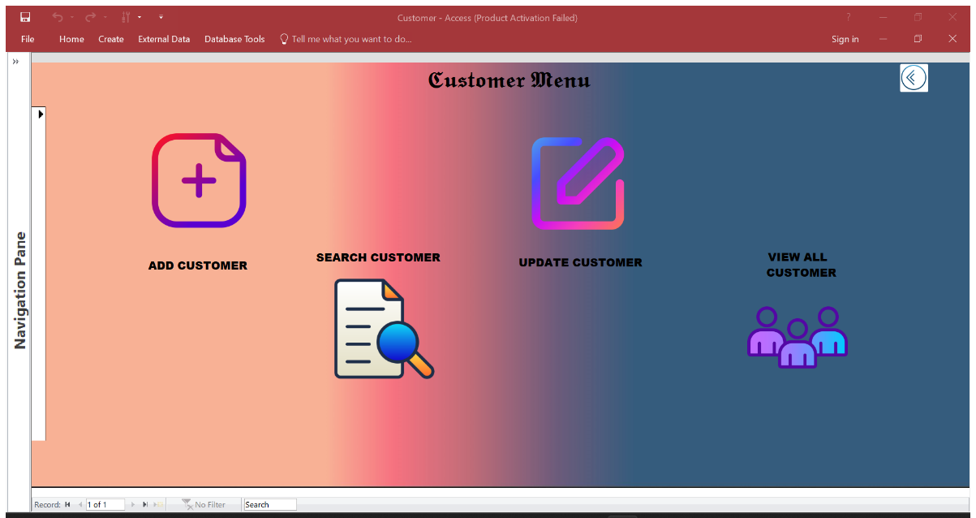

* 1. Leads 🡪

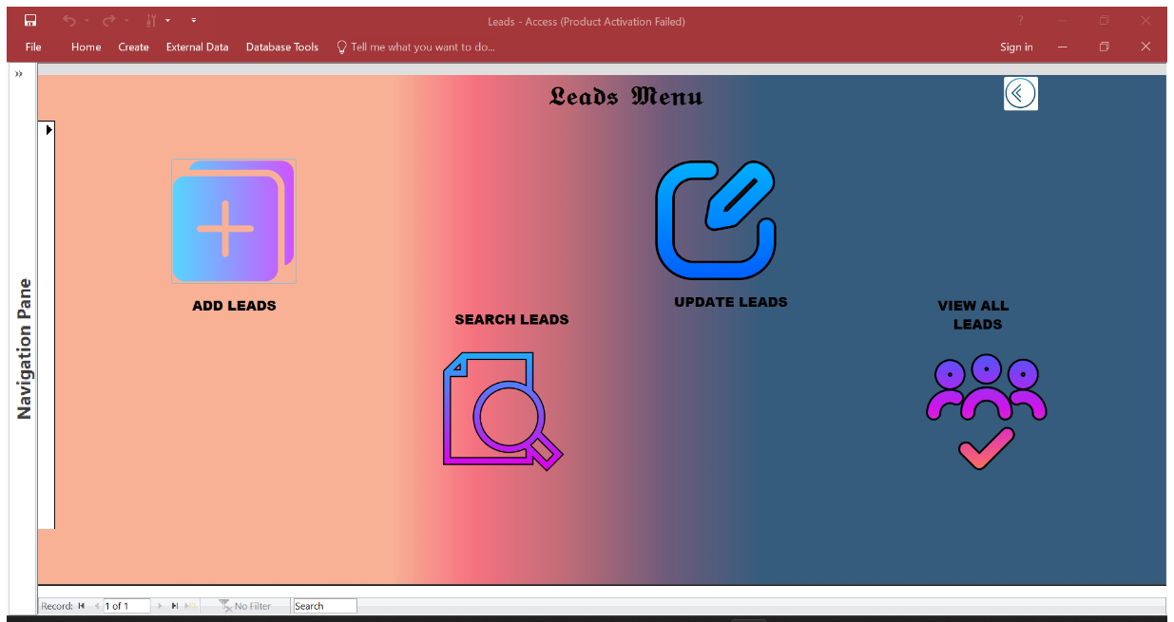

* 1. Opportunity 🡪

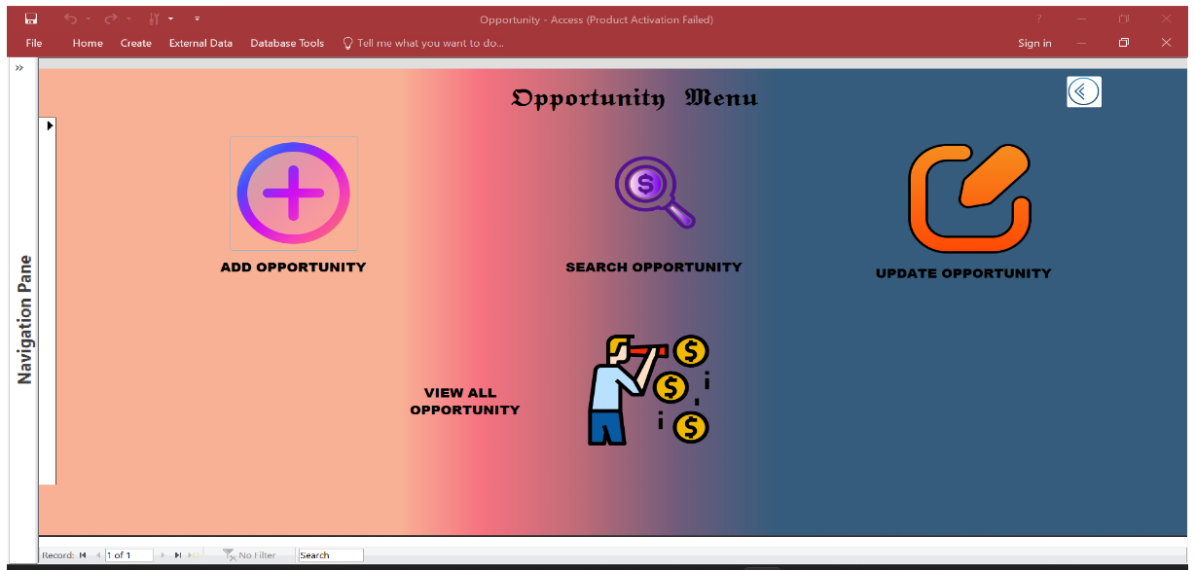

* 1. Sales Representative 🡪

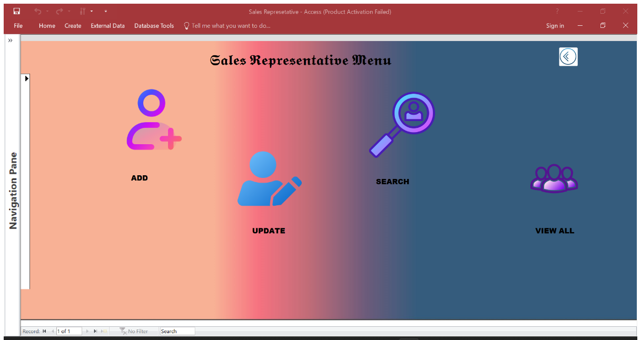

* 1. Tasks 🡪

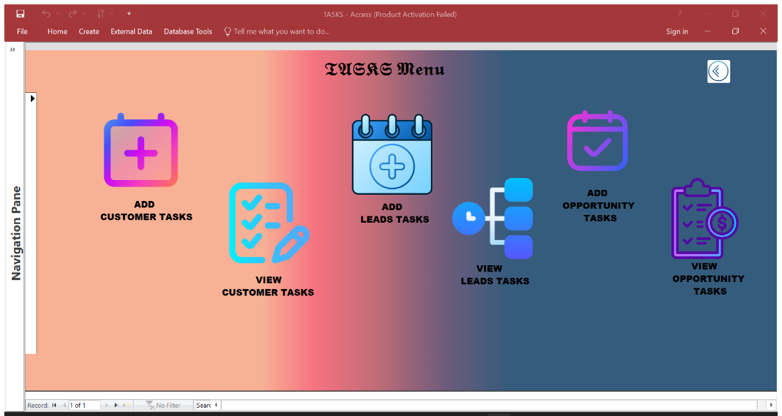

* 1. Interactions 🡪

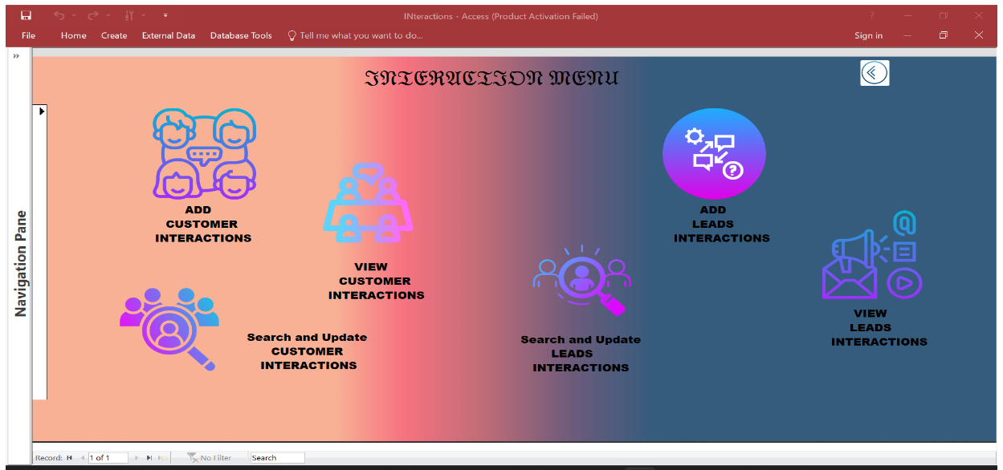

* 1. REPORT 🡪

